Project report for the Degree of B.Sc. Engineering

**Java Web Application:  
Online Admission System**

**Bisnu Chandra Sarkar**

**Student ID: 16CSE039**

Department of Computer Science & Engineering

Bangabandhu Sheikh Mujibur Rahman Science and Technology University

Gopalganj, Bangladesh

January, 2019

**Online Admission System**

**By**

**Bisnu Chandra Sarkar**

**Student ID: 16CSE039**

**Supervised by**

**Md. Akkas Ali**

Submitted to the Department of Computer Science & Engineering

Bangabandhu Sheikh Mujibur Rahman Science and Technology University in partial fulfillment to the requirements for the degree

Of B.Sc. Engineering

**Project Approval**

Student’s Name: Bisnu Chandra Sarkar

Student’s ID: 16CSE039

Project Title: **Online Admission System**

We the undersigned, recommend that the project completed by the student listed above, in partial fulfillment of B.Sc. Engineering degree requirements, be accepted by the Department of Computer Science and Engineering, Bangabandhu Sheikh Mujibur Rahman Science and Technology for deposit.

**Supervisor Approval\***

**………………………………..**

Md. Akkas Ali

Assistant Professor and Chairman

Department of Computer Science and Engineering

**Bangabandhu Sheikh Mujibur Rahman Science and Technology University, Gopalganj, Bangladesh**

**Abstract**

Technology is developing day by day. As according to that expectations of people are growing up day by day. If we want to say precisely that will be people want to do maximum works through online. That helps to save time and energy. One of our important work of our today’s world is to admit to any school, college, university or anywhere. Thus we have to fill up many information at that cases it will be easier to anyone to fill up the information and complete admission remaining at home through online. Thus it getting popular day by day such systems are become necessary parts. This article describes such a system that able to help us to familiar with such admission systems.

**Acknowledgement**

Firstly I want to show my gratitude to my respected teacher Md. Akkas Ali sir for allowing me to work on this project. When I started the project, I didn’t know how to do this. Firstly my friend Sifat Sikder helps me to be familiar with such terms like java servlet, jsp through which I do my project. I am thankful to him. At the middle point of my project I get on a trouble to working with database. At that moment, Tahmid hasan vai helps me to resolve the problem. I am really thankful to him.

I would like to express my heartfelt thanks to all of my well-wisher who are always inspired me to do well in my life.

Bisnu Chandra Sarkar

January, 2019

**Table of Content**

**Abstract 4**

**Acknowledgement 5**

**Table of Content 6**

**Chapter 1 Introduction 7**

* 1. Introduction 7
  2. Background and Present State 7
  3. Motivation and Aims 8
  4. Objectives 8
  5. Organization of the paper 8

**Chapter 2 Literature Review 9**

2.1 Introduction 9

2.2 Related Work 9

**Chapter 3** Proposed Methodologies **10**

3.1 Description of the Methodology

**Chapter 4 Implementation 11**

4.1 Collection of required elements 11

**Chapter 5 Experimental View 12**

**Chapter 6 Conclusion and Recommendation 16**

7.1 Conclusion 16

7.2 Future Work 16

**References 17**

**Chapter 1**

**Introduction**

* 1. **Introduction**

In the era of technology everyone are connected through internet. Now, People can’t think ownself without internet. So maximum people are now familiar with web based systems. People are like to do tasks through online. So online applications are getting popular day by day. This projects is related to such applications. Students who are allowed to admit in the Department Of Computer Science & Engineering, Bangabandhu Sheikh Mujibur Rahman Science & Technology University are able to complete their admission of every semester and see the admission status through this application.

* 1. **Background and Present State**

There exists so many web applications already have built. That applications helping through some services like online hotel booking, online book store, online examination etc. One of the most familiar service of web application is online Registration system. This service inspire to get familiar with online admission system. So now in many places are getting connected with online admission system.

**1.3 Motivation and Aims**

Actually I get motivated to do this project when I staying in a long queue at the time of payment of my admission. Another thought motivated me to do this project; That is, If I submitted my static datas at a moment that should be saved on database and I have not to resubmit them again. Those two problems can be resolved through online admission system. I am tried to solve such problems through my project.

* 1. **Objectives**

The main objectives for this projects are listed below:

* Complete admission through online.
* Complete payment through online.
* See application status of admission through online.
  1. **Organization of the paper**

The remaining chapter of the paper is organized as follows. In chapter 2 describes the literature review and related work on web application. Chapter 3 briefly describes important and technical terminologies of the paper. Implementation of my web application idea has been described in chapter 4. Application analysis has been shown in chapter 5. Discussion of my web application as well as the future plan on the spplicstion are shown in chapter 6.

**Chapter 2**

**Literature Review**

**2.1 Introduction**

In today’s world, internet created a different dimension in our life. That is not only make our work easier but also help to save time and energy. In accordance to that web applications are getting priority everywhere day by day. There created so many web application frameworks like Django, Ruby on rails, Sympony to making the web applications easier.

**2.2 Related Work**

There are many other web application are available related to it. Some of them are:

* Online Hotel Booking*.*
* Online Examination System
* Online Quiz
* Online book store*.*

**Chapter 3**

**Proposed Methodology**

**3.1 Description of the Methodology**

The purpose of this project is to get admit through online. In the first page there are four options; They are: Home, Admission, Applicaion and About. Through clicking “Home” only able to show homepage. If we click on “Admission” we get two options. If we are not submitted personal information yet we have to click on No and have to submit personal information. Then we get the payment page. Completing the payment through bkash we will get a transaction ID. Through submitting this transaction ID we can complete the admission. We will be able to see our admission status through clicking on “Application Status”.

**Result:** At last the result will be made according to the procedure.

**Chapter 4________________________________________________________________**

**Implementation**

**4.1 Collection of required elements**

This application is made with a collection of elements connected and collaborated with each other. They are:

* Eclipse as platform
* Xampp as database server
* Tomcat as java servlet container
* JSP for generating web pages
* Java as language

**Chapter 5**

**Experimental view**

Figure 5.1 shows the Homepage.

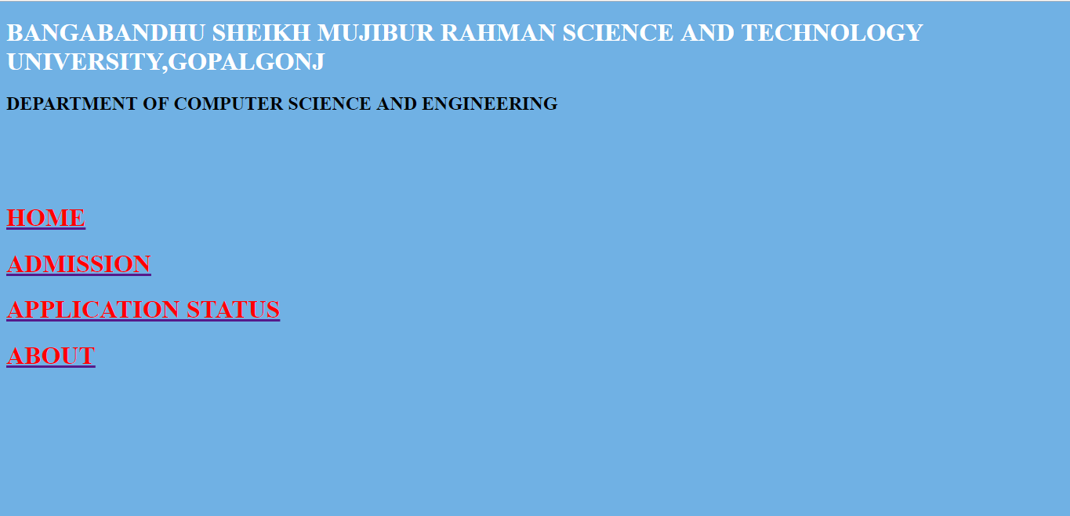

Figure 5.1 Homepage

Figure 5.2 shows the first page of admission

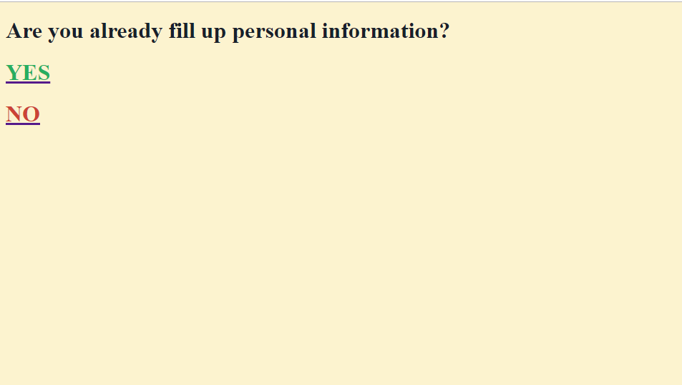

Figure 5.2 First page of admission

Figure 5.3 shows the personal information.

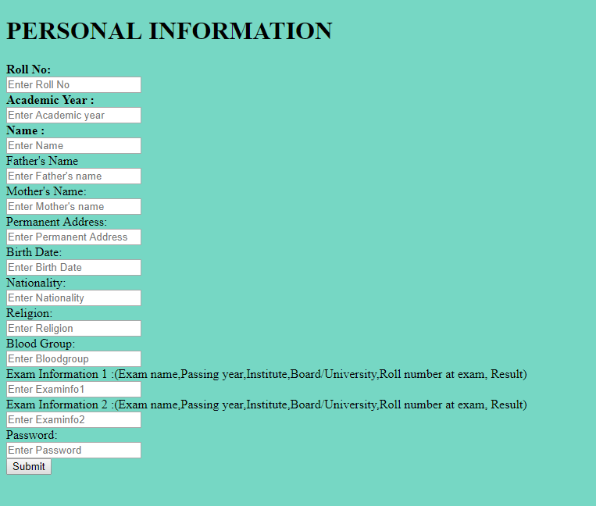

Figure 5.4 shows the payment page.

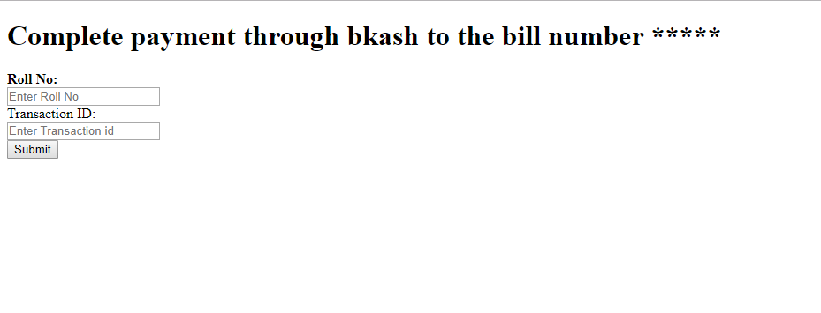

Figure 5.5 shows admission status:

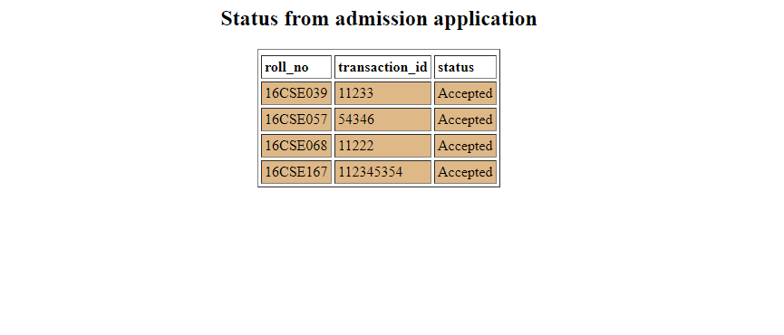

**Chapter 6**

**Conclusion and Recommendation**

**6.1 Conclusion**

I tried so much to maintain all the worst cases that can happen. But I don’t able to handle all of them. Actually when I firstly started to do it I don’t think that I will be fall into the ocean of problems. But I tried to getting out the problems as much as I can from the project.

**6.2 Future Work**

I confess that my application has lots of limitations. Actually I wanted to connect the database with bkash and according to the information the database will be updated. I don’t able to it. The another limitation is I don’t add any delate option that the information can be delated. In future, I want to resolves such big problems and make it as real life applicable application.

**_______________________________________________________________________________________**

**References**

1. http://www.telusko.com/
2. [**https://www.javatpoint.com/servlet-tutorial**](https://www.javatpoint.com/servlet-tutorial)
3. https://www.javatpoint.com/jsp-tutorial
4. https://www.javatpoint.com/dbms-tutorial
5. <https://www.w3schools.com/html/default.asp>
6. <https://www.wikipedia.org/>